**LIT ASSIGNMENT -DAY 10**

**Batch: SAP ABAP ON HANA**

**EMP ID:46255236**

**Assignment 3 – Business Add in (BADI)-Single Use.'**

* Define a BADI (ZBADI_DEMO_01…05) in SE18.

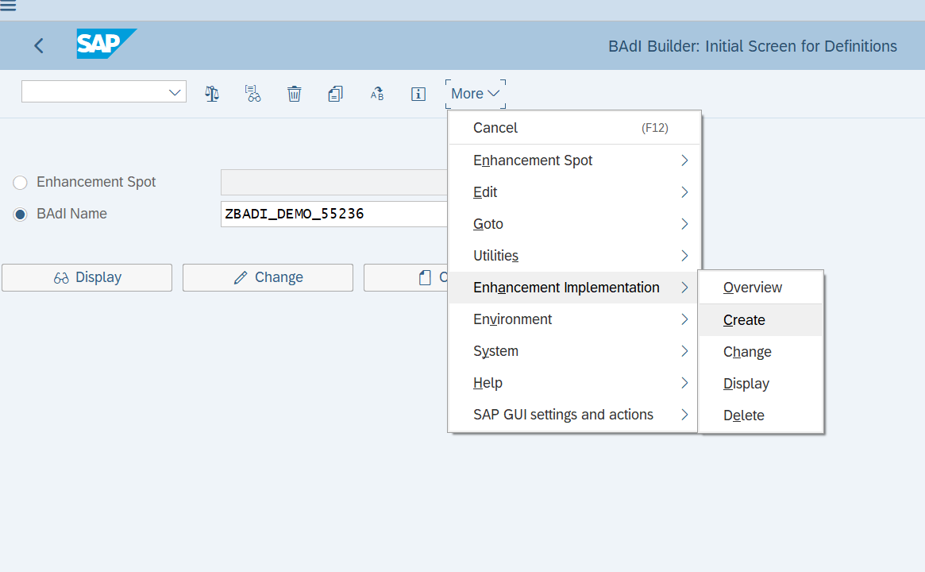

* Double click on the interface created to define the methods, parameters and exceptions.

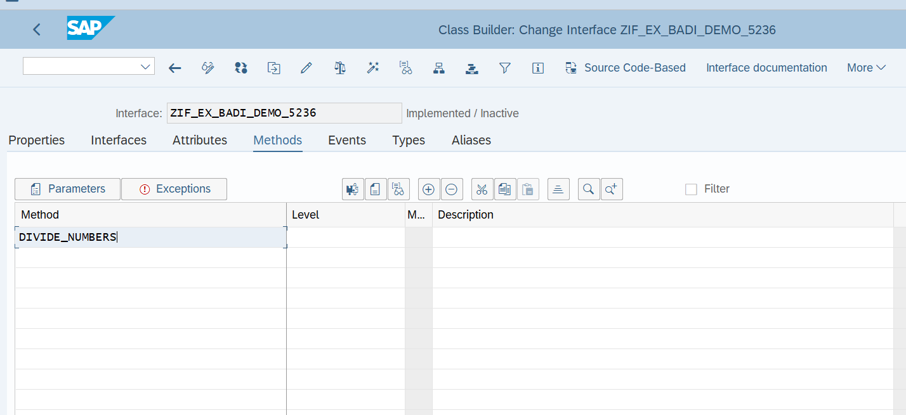

Create an implementation (ZBADI_DEMO_IMP_01...05) by specifying the BADI name that was created in step1.

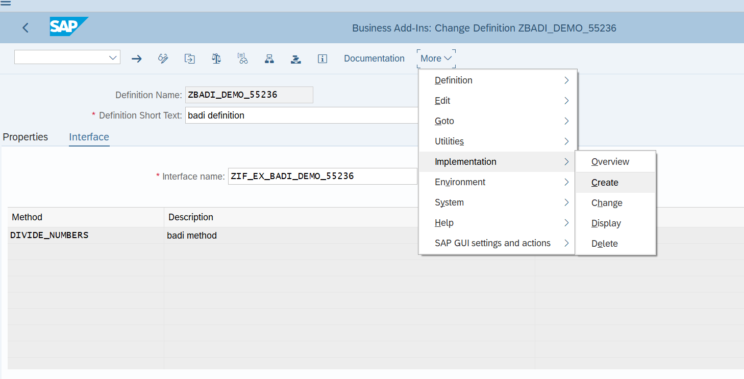

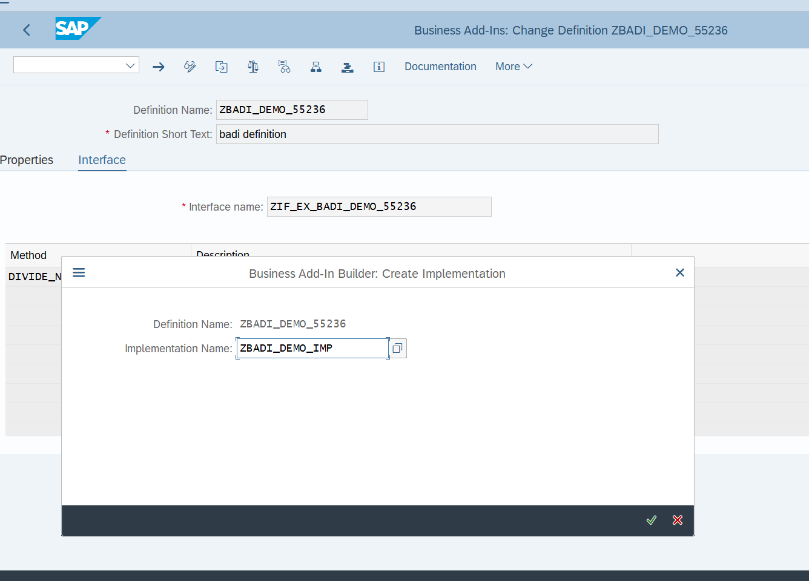

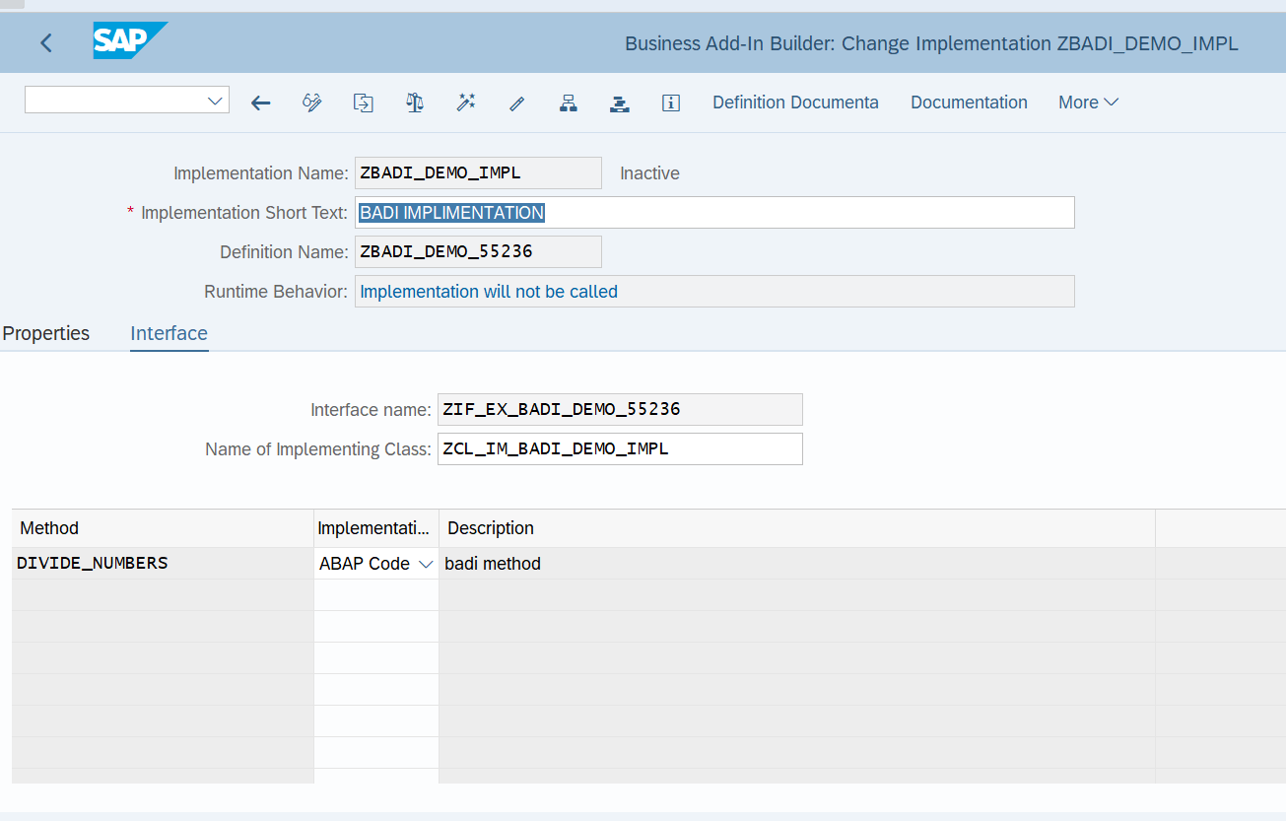

Step7: Double click on the method and write the source code to divide the two numbers.

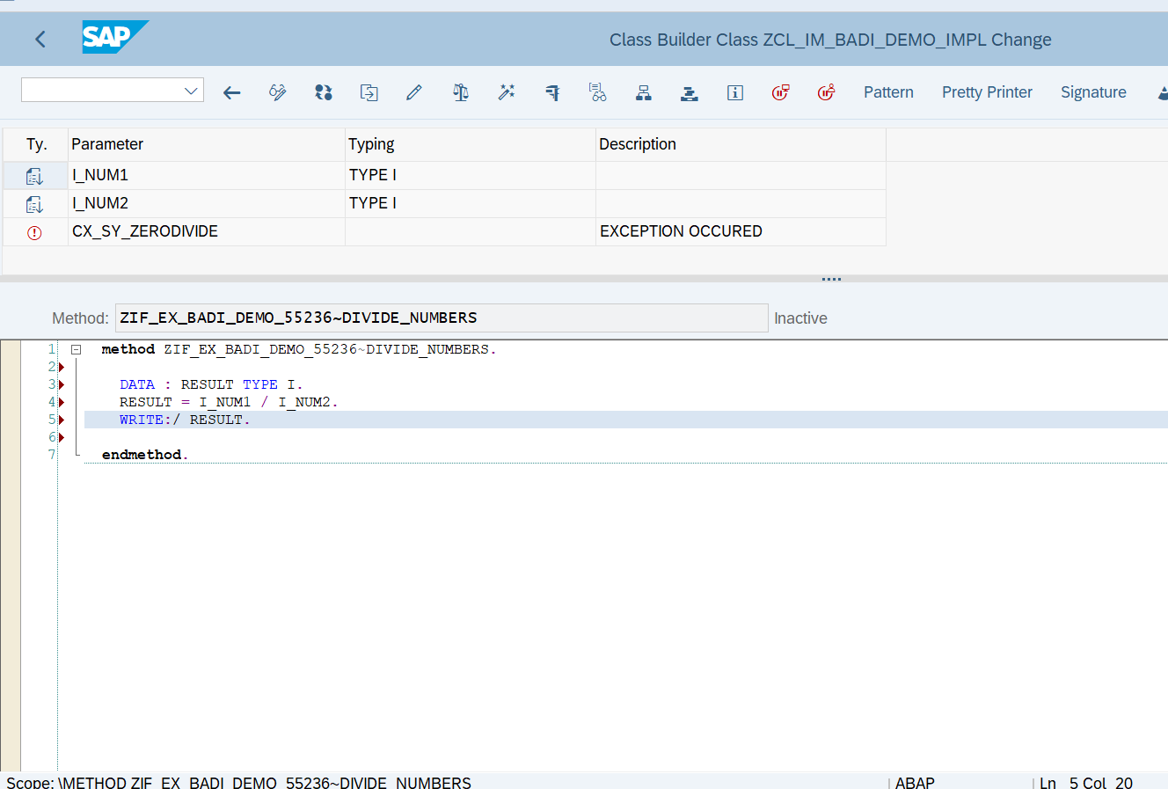

**REPORT:**

REPORT Z5236_BADI_DEMO.  
  
START-OF-SELECTION. CLASS CL_EXITHANDLER DEFINITION LOAD.  
DATA: RESULT TYPE I.  
DATA OBJ1 TYPE REF TO ZIF_EX_BADI_DEMO_55236.  
  
PARAMETERS: NUM1 TYPE I,  
            NUM2 TYPE I.  
  
CALL METHOD cl_exithandler=>get_instance  
  EXPORTING  
    exit_name                     =  'ZBADI_DEMO_55236'  
*    null_instance_accepted        = SEEX_FALSE  
*  IMPORTING  
*    act_imp_existing              =  
  CHANGING  
    instance                      = OBJ1  
  EXCEPTIONS  
    no_reference                  = 1  
    no_interface_reference        = 2  
    no_exit_interface             = 3  
    class_not_implement_interface = 4  
    single_exit_multiply_active   = 5  
    cast_error                    = 6  
    exit_not_existing             = 7  
    data_incons_in_exit_managem   = 8  
    others                        = 9  
        .  
IF sy-subrc <> 0.  
* Implement suitable error handling here  
ENDIF.  
  
TRY.  
  CALL METHOD obj1->divide_numbers  
      EXPORTING i_num1 = NUM1  
                i_num2 = NUM2 .  
 CATCH cx_sy_zerodivide .  
     
   ENDTRY.

OUTPUT:

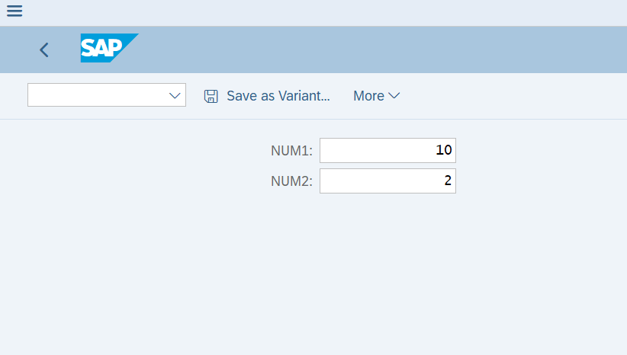

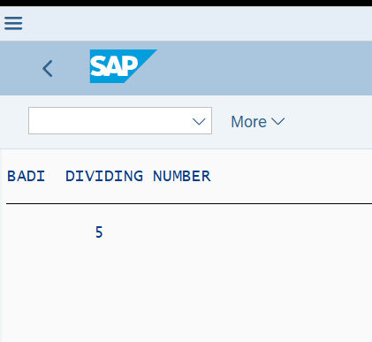

**Assignment 4 – Business Add in (BADI)-Multiple Use**

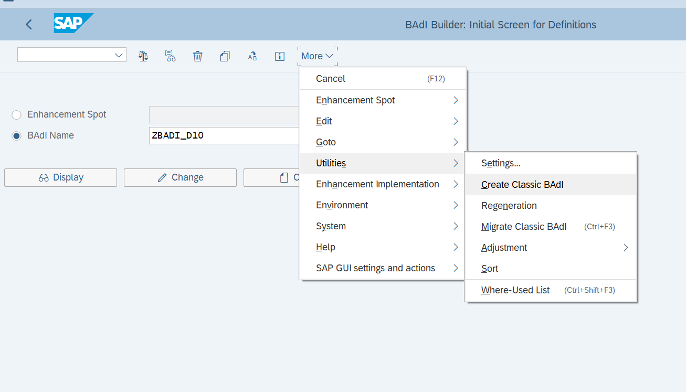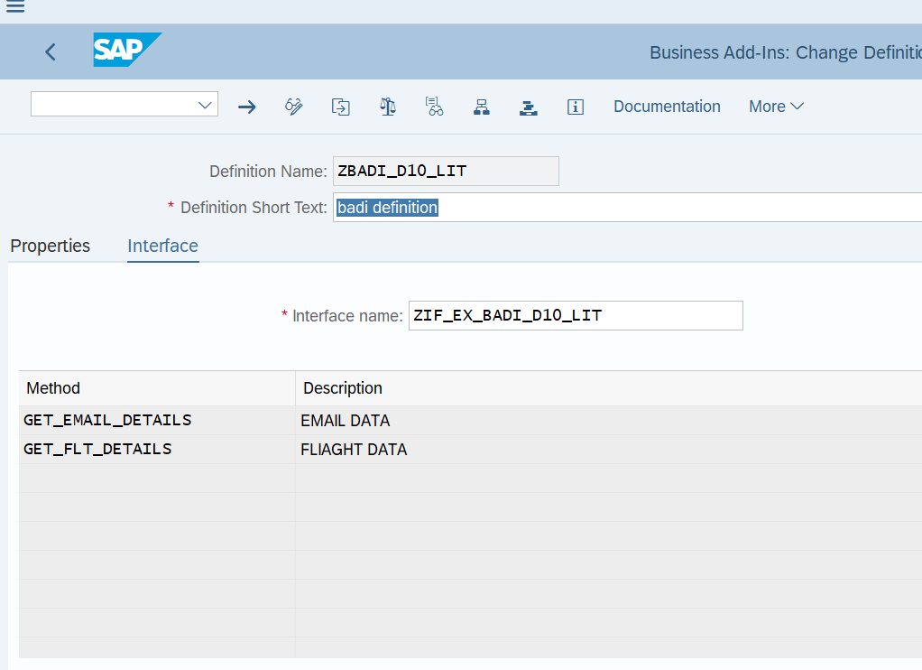

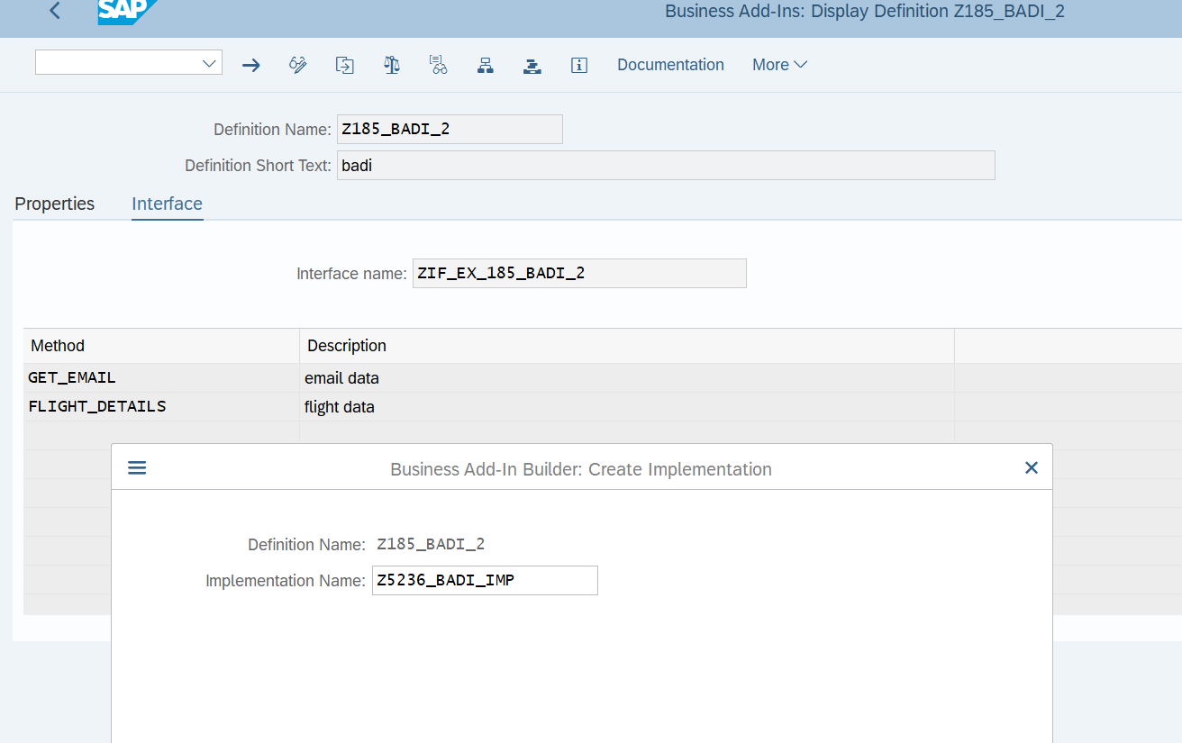

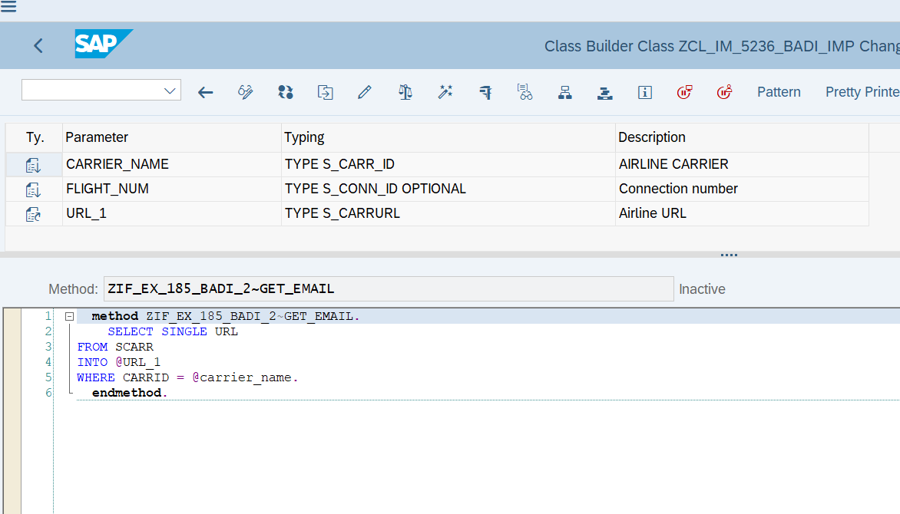

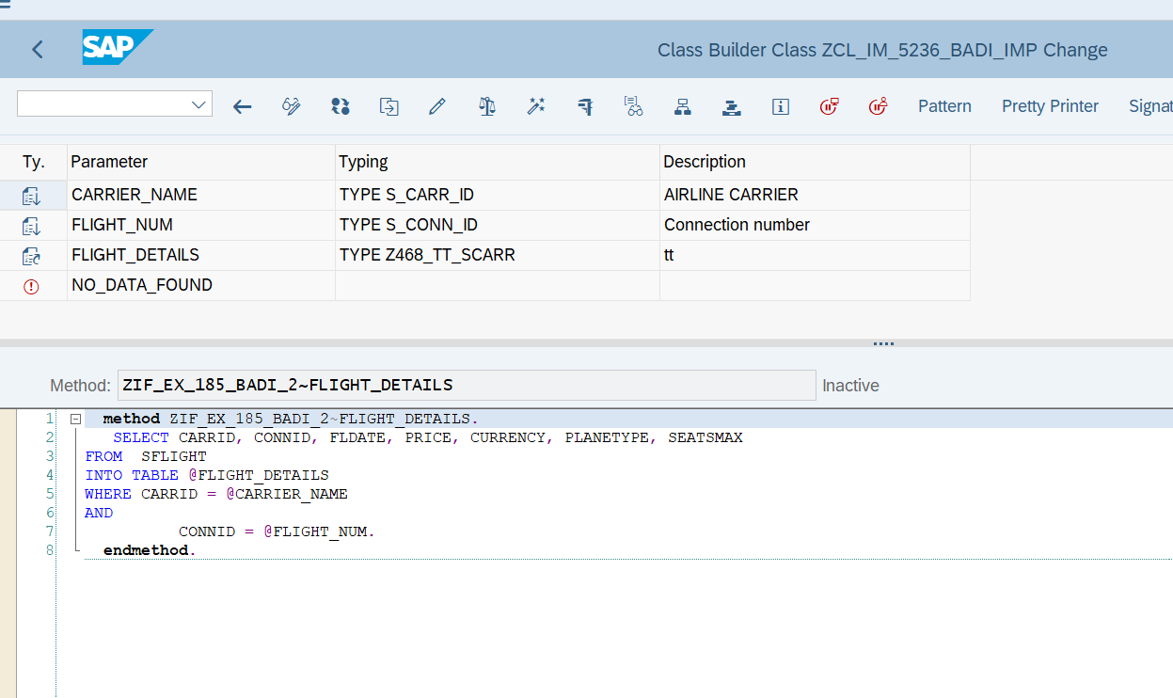

REPORT:

REPORT Z5236_D10_LIT_Q4.  
  
DATA: OBJ TYPE REF TO ZIF_EX_BADI_D10_LIT.  
  
PARAMETERS: p_carr TYPE S_CARR_ID,  
            P_flight TYPE S_CONN_ID.  
  
  
DATA : it_flight TYPE  Z468_TT_SCARR,                          *" declaring internal table of sflight*  
       gs_sflight TYPE line of Z468_TT_SCARR,  
       url type s_carrurl.  
CL_EXITHANDLER=>GET_INSTANCE(  
EXPORTING  
    EXIT_NAME                     =  'ZBADI_D10_LIT'   *" Business Add-In Definition*  
*\*    NULL_INSTANCE_ACCEPTED        =     " Is Null Instance OK if There Is no Active Implementation?*  
*\*  IMPORTING*  
*\*    ACT_IMP_EXISTING              =     " Returns an Active Implementation*  
CHANGING  
    INSTANCE                      =  OBJ   *" Instance*  
EXCEPTIONS  
    NO_REFERENCE                  = 1  
    NO_INTERFACE_REFERENCE        = 2  
    NO_EXIT_INTERFACE             = 3  
    CLASS_NOT_IMPLEMENT_INTERFACE = 4  
    SINGLE_EXIT_MULTIPLY_ACTIVE   = 5  
    CAST_ERROR                    = 6  
    EXIT_NOT_EXISTING             = 7  
    DATA_INCONS_IN_EXIT_MANAGEM   = 8  
OTHERS                        = 9  
).  
IF SY-SUBRC <> 0.  
*\* MESSAGE ID SY-MSGID TYPE SY-MSGTY NUMBER SY-MSGNO*  
*\*            WITH SY-MSGV1 SY-MSGV2 SY-MSGV3 SY-MSGV4.*  
ENDIF.  
  
CALL METHOD obj->get_flt_details  
  EXPORTING  
    carrier_name   = p_carr  
    flight_num     = p_flight  
  CHANGING  
    flight_details = it_flight  
*\*  EXCEPTIONS*  
*\*    no_data_found  = 1*  
*\*    others         = 2*  
        .  
IF sy-subrc <> 0.  
*\* Implement suitable error handling here*  
ENDIF.  
  
  
  
  
  
CALL METHOD obj->get_email_details  
  EXPORTING  
    carrier_name = p_carr  
    flight_num   = p_flight  
  CHANGING  
    url          = url  
    .  
  
  
  
WRITE: / 'Airline URL is' COLOR COL_POSITIVE,  url.  
WRITE: 40 'Flight Details' COLOR COL_POSITIVE.  
WRITE: / 'CARRID',  
10 'CONNID',  
20 'FLDATE',  
31 '      PRICE',  
52 'CURRENCY',  
63 'PLANETYPE',  
75 'SEATSMAX'.  
ULINE.  
LOOP AT it_flight INTO gs_sflight.  
WRITE : /  gs_sflight-carrid LEFT-JUSTIFIED,  
10 gs_sflight-connid,  
20 gs_sflight-fldate,  
31 gs_sflight-price,  
52 gs_sflight-currency,  
63 gs_sflight-planetype,  
75 gs_sflight-seatsmax.  
ENDLOOP.

OUTPUT:

